C PROGRAMMING FOR LINEAR SEARCH

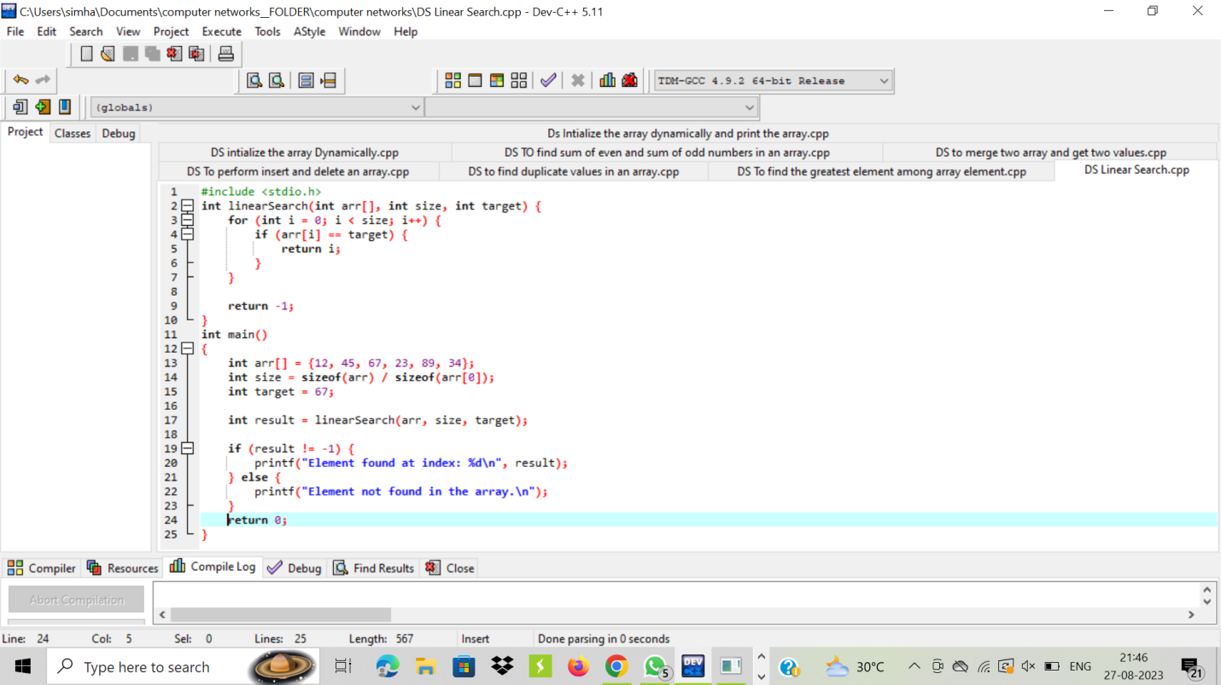

OUTPUT:

